**Test Plan:**

A test plan is a detailed document which describes software testing areas and activities. It outlines the test strategy, objectives, test schedule, required resources (human resources, software, and hardware), test estimation and test deliverables.

The test plan is a base of every software's testing. It is the most crucial activity which ensures availability of all the lists of planned activities in an appropriate sequence..

The test plan is a template for conducting software testing activities as a defined process that is fully monitored and controlled by the testing manager. The test plan is prepared by the Test Lead (60%), Test Manager(20%), and by the test engineer(20%).

There are three types of test plan they are

* Master Test Plan
* Phrase Test Plan
* Specific Test Plan

**Master Test Plan:**

Master Test Plan is a type of test plan that has multiple levels of testing. It includes a complete test strategy.

**Phrase Test Plan:**

A phase test plan is a type of test plan that addresses any one phase of the testing strategy. For example, a list of tools, a list of test cases, etc.

**Specific Test Plan:**

Specific test plan designed for major types of testing like security testing, load testing, performance testing, etc. In other words, a specific test plan designed for non-functional testing.

**Test Plan Components :**

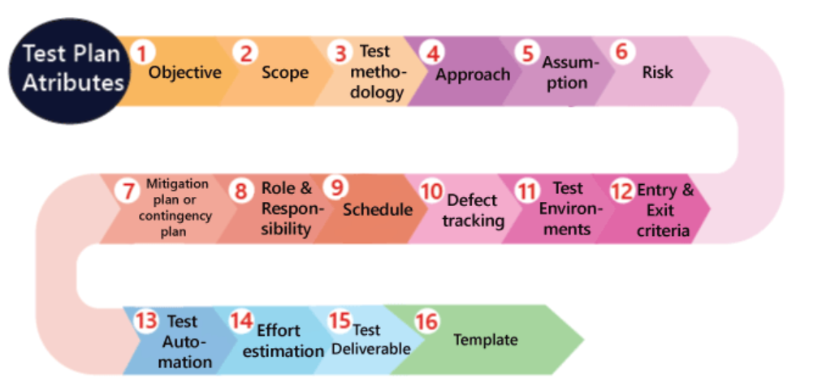

**Objective :**  It consists of information about modules, features, test data etc., which indicate the aim of the application means the application behavior, goal, etc.

**Scope :** It contains information that needs to be tested with respective of an application

**In Scope :** These are the modules that need to be tested rigorously (in-detail).

**Out Scope :** These are the modules that need to be tested rigorously (in-detail).

**Test Methodology :** It contains information about performing a different kind of testing like Functional testing, Integration testing, and System testing, etc.

**Approach** : This attribute is used to describe the flow of the application while performing testing and for the future reference.

The approach can be classified into two parts which are as following:

* Top to bottom approach
* Bottom to top approach

**Assumption:**

It contains information about a problem or issue which maybe occurred during the testing process and when we are writing the test plans, the assured assumptions would be made like resources and technologies, etc.

**Risk:**

These are the challenges which we need to face to test the application in the current release and if the assumptions will fail then the risks are involved.

**For example,** the effect for an application, release date becomes postponed.

**Mitigation Plan or Contingency plan :**

It is a back-up plan which is prepared to overcome the risks or issues.

**Role & Responsibility :**

It defines the complete task which needs to be performed by the entire testing team. When a large project comes, then the **Test Manager** is a person who writes the test plan. If there are 3-4 small projects, then the test manager will assign each project to each Test Lead. And then, the test lead writes the test plan for the project, which he/she is assigned.

**Schedule :** It is used to explain the timing to work, which needs to be done or this attribute covers when exactly each testing activity should start and end? And the exact data is also mentioned for every testing activity for the particular date.

**Defect tracking** :

It is generally done with the help of tools because we cannot track the status of each bug manually. And we also comment about how we communicate the bugs which are identified during the testing process and send it back to the development team and how the development team will reply. Here we also mention the priority of the bugs such as high, medium, and low.